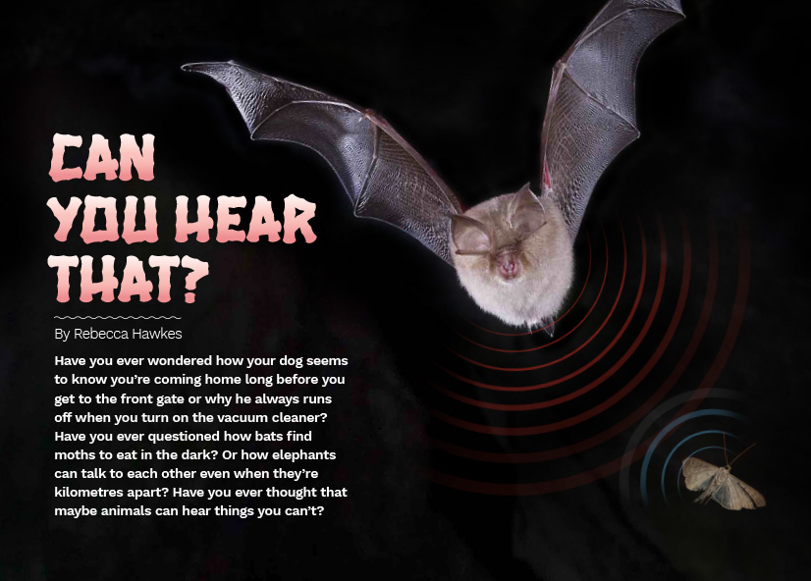
Connected
Level 4
2016

Can You Hear That?
by Rebecca Hawkes

Overview
This article addresses a series of questions about how sound is created and perceived. It compares the hearing ability of humans with a range of different animals. It also touches on the sonar technology that has been useful for human purposes but can have negative consequences for animals.
A Google Slides version of this article is available at www.connected.tki.org.nz.

Curriculum contexts

SCIENCE: Nature of Science: Communicating in science  Level 4 – Begin to use a range of scientiﬁc symbols, conventions, and vocabulary. | Key Nature of Science ideas  Scientists:  - recognise how a model or representation does and doesn't match the science  - use a variety of scientific representations, including models, diagrams, graphs, and text, to help them understand and explain things that we can't see, like sound and air particles.
SCIENCE: Physical World: Physical inquiry and physics concepts  Level 4 – Explore, describe, and represent patterns and trends for everyday examples of physical phenomena, such as … sound and waves.  SCIENCE: Living World: Life processes  Level 4 – Recognise that there are life processes common to all living things and that these occur in different ways. | Key science ideas  - Sound is a form of energy that, like all other forms of energy, can be transferred or transformed into other types of energy.  - Sound is caused by vibrations of particles in a medium (solid, liquid, or gas).  - Sound waves can be described by their wavelength, frequency, and amplitude.  - The pitch of a sound is related to the wavelength and frequency.  - Many animals have developed ways of detecting sound vibrations. Detecting sound can help them survive.
ENGLISH: Reading  Level 4 – Ideas: Students will show an increasing understanding of ideas within, across, and beyond texts. | Indicators  - Makes meaning of increasingly complex texts by identifying and understanding main and subsidiary ideas and the links between them.  - Makes connections by thinking about underlying ideas within and between texts from a range of contexts.  - Recognises that there may be more than one reading available within a text.  - Makes and supports inferences from texts with increasing independence.

The New Zealand Curriculum

Science capability: interpret representations

Capability overview
Scientists represent their ideas in a variety of ways. They might use models, graphs, charts, diagrams, photographs, and written text. A model is a representation of an idea, an object, a process, or a system. Scientists often use models when something is not directly observable. Models enable scientists to work on their ideas, even though they are often using a limited representation of the “thing” itself. It is important students can identify what is the same and what is different about the model and the thing. | It is important for students to think about how data is presented and ask questions such as:  - What does this representation tell us?  - What is left out?  - How does this representation get the message across?  - Why is it presented in this particular way?  This sort of questioning provides a foundation to critically interact with ideas about science in the media and to participate as critical, informed, and responsible citizens in a society where science plays a significant role.

More about the capability

The capability in action
The science capability “Interpret representations” is about students understanding information that is presented as a description or in visual form and recognising the best way to present information.  Scientific representations include diagrams, models, charts, and graphs, as well as written text.  Scientists develop models and diagrams that best represent their theories and explanations.  Scientists  Scientists use:  - representations that can help both the original scientist and others clarify, critique, and evaluate their ideas, research, and theories  - computer and other kinds of modelling to predict what might happen in certain conditions and then test these predictions to see how accurate the model or idea is  - diagrams or models to communicate science ideas  - graphs to present data  - scientific forms of text involving argumentation that use evidence to debate explanations.  Students  Students should have opportunities to:  - learn to interpret a variety of representations, including models, diagrams, graphs, and text  - develop their own representations of scientific ideas, for example, through modelling using concrete materials or using their own bodies in mime and drama  - recognise how the model or representation matches the science idea and how it is different  - consider and critique a range of representations, including scientific texts, newspaper articles about scientific matters, online information about science matters, and scientific representations developed by their peers. | Teachers  Teachers can:  - help students to be more critical consumers of science information by being explicitly critical themselves and modelling useful questions  - support students to evaluate how information is presented, for example, to assess if a graphical representation has been done appropriately or is it misleading  - ask questions such as:  - What do you think this representation tells us?  - What do the (arrows, lines, symbols, etc.) mean? (that is, help your students interpret the features)  - Is anything left out? Do you think anything is missing?  - How does this get the message across?  - Is there anything more you need to know to be able to interpret this representation?  - How does the representation make the science idea clear?  - Which aspects of this representation could mislead the reader?  - Why is it presented in this way?  - Could you suggest a better way to represent it?  - establish a science classroom culture by:  - modelling and encouraging a critical stance  - encouraging students to consider the quality and interpretation of scientific representations  - introducing learning conversations that involve interpreting, critiquing, and developing representations to demonstrate the idea's relevance in everyday life.

More activities to develop the capability

Meeting the literacy challenges

The challenges in the text require students to integrate complex information from explanations with visual representations to build their understanding of sound. Another literacy demand lies in understanding and using topic specific scientific, technological, and biological vocabulary to interpret the ideas and information.  The article moves from describing what sound is to how we and other animals hear, why we lose our hearing, and how sound is used to tell us more about our underwater world. Students need to apply their understanding from one topic to the next to gain a deeper knowledge of the concepts. | The following strategies will support students to understand, respond to, and think critically about the information and ideas.  You may wish to use shared or guided reading, or a mixture of both, depending on your students’ reading expertise and background knowledge.  After reading the text, support your students to explore the activities outlined in the following pages.

INSTRUCTIONAL STRATEGIES

Finding the main ideas  Have the students read the title and first paragraph. Ask them to think, pair, and share their responses to the questions. Ask them to SCAN the headings and diagrams to get a sense of what they will learn from the text. Clarify the author’s purpose, which is to explain what sound is and how people and other animals are able to hear. ASK QUESTIONS to help the students make connections to their prior knowledge.  - How do you think sound is created? What words do people use when they talk about sound?  - How do you think people hear? What do you call the different parts of the ear?  - Do other animals hear the same way as we do?  - What questions do you have about sound and hearing?  RECORD the students’ predictions and questions on a graphic organiser such as the one below. After the reading, have them check whether their predictions were correct and whether their questions were answered.  Before the reading After the reading  Our predictions What we found out  Our questions What we found out  New questions  Encourage them to REFLECT on what else they might like to learn about sound and hearing.  - What have you learned that you didn’t know before?  - Have any new questions arisen?  - What else might you like to find out?  The Hearing Association of New Zealand estimates that around 700,000 New Zealanders have some form of hearing loss. This makes it likely that some of your students have special knowledge or experiences they can contribute, either because they are hearing impaired themselves or because they have family members who have a hearing impairment. Be careful to take an inclusive and strengths-based approach to such discussion. | Dealing with scientific vocabulary  EXPLAIN that the text contains a considerable amount of scientific vocabulary but that many of the terms are compound words, or words made up of a root word joined to a suffix or prefix. Remind the students that this means they can often work out the meaning of the unfamiliar word by pulling it apart and then using what they know to put it together again. Learning the meaning of prefixes and root words also helps them to unpack similar words when they encounter them. Focus on the words “infrasonic”, “ultrasonic”, and “sonar”. Provide the students with reference tools, such as a dictionary, thesaurus, and the Internet, so that they can do some research and report back to the class on the meanings of the words.  - Can you explain the meanings of these words to a partner?  - Based on the definitions in the article, what do you think the prefix “ultra” means? What about “infra”? How does your definition compare with one in another resource?  - How do you think the words “infrasonic” and “ultrasonic” might be related to the word “sonar”?  - What other words use the prefix “infra” or “ultra” or the root word “sonic”? What do they mean?  This means: It can be used to make these scientific terms:  Ultra (prefix)  Infra (prefix)  Sonic (root word)  Sonar (root word)  The students may like to try a similar approach for unpacking or reinforcing other terms in the article, such as “echolocation”, “wavelength”, “high frequency”, and “low frequency”. MODEL using these terms as you work through the activities and encourage the students to use them, too.  Using diagrams and visual features  EXPLAIN that the text has numerous diagrams and charts. Remind them of the importance of reading the headings and all the labels.  - The writer says that a diagram of a sound wave can tell you a lot about what the sound is like. What can you work out from the diagrams on pages 19 and 20?

Meeting the literacy challenges

Bear in mind that diagrams of sound are often presented as though the sound is linear; travelling out from the source in just one direction. The diagram on page 19 is intended to show that sound travels out in all directions from the source of vibration.  - Where is the source of the various kinds of vibration shown on the diagram? Where does the vibration go?  - How well does it show that sounds travel in all directions? How could we better show that sound travels out in all directions?  - Where on the diagram can you see the particles being squashed together (compressed)? Where are they further apart (rarefied)?  - Does this diagram help you to understand how sound travels? Why or why not?  - What happens to particles in the air when we pluck a guitar string? (You could pluck a guitar string, or make some other sound, to help the students connect the theoretical representation in the diagram to the practical reality.)  The diagram on page 20 is intended to represent the three characteristics of sound waves: amplitude, frequency, and wave length. Split the class into six groups and give each group one of the definitions. ASK them to find a simple way to explain it and present it to the rest of the class, commenting on how the diagram demonstrates the characteristic. Have them critique each other’s explanations for accuracy. The text provides examples of the different sorts of sounds. ASK if they can think of some more.  Check the students’ understanding by giving each group some graph paper and ask them to sketch three diagrams:  - Have them sketch two diagrams of a sound with the same pitch, but the second diagram should be louder. (The sounds will have the same wavelength and frequency, but the second diagram will have greater amplitude.)  - The third diagram should show a sound with a higher pitch than the second diagram. (It will have a higher frequency and a shorter wavelength.)  - Ask students to explain what would be different about the movement of the particles in each of the three diagrams. | ASK the students to explain what they can see in the diagram on page 21.  - Why has the designer chosen to represent the ear like this?  - What can you learn by looking closely at this diagram?  - What helps you understand how we hear sound?  PROMPT them to notice that the diagram shows how our ears pick up sound waves and transform them into sounds we can hear. EXPLAIN that this is a sequential process and it could be represented on a flowchart. Demonstrate how to create a flowchart, and let the students complete them themselves.  Discuss the diagram showing the hearing ranges of different mammals and ask students to compare what other sources say about these ranges. (See, for example, this infographic: www.myihp.co.uk/animal-hearing-ranges/) PROMPT discussion about how different testing conditions and variables can produce difference results. EXPLAIN that in this instance, as part of the writing process, the writer has checked the figures extensively in academic sources. However, it was necessary to add a proviso (in the caption) because of the variability for different species and because the loudness of the sound also affects the hearing range recorded.  - What is the main idea in the diagram? Does the knowledge that other diagrams show different figures affect your ability to accept the information?  - Why do you think the writer felt it was important to add this proviso?  - How do you think scientists find out the range of frequencies that animals can hear?  Using the diagram demonstrating echolocation, have the students create flowcharts that explain the process. They could do this in pairs and then compare their flowcharts with another pair, looking for accuracy and clarity.  On pages 24 and 25, the designer has combined a photograph with a hand-drawn illustration. DISCUSS why this has been done and what the blue and red arcs mean.  - How do these images help you to understand the ideas in the text?

Reading standard: by the end of year 8
The Literacy Learning Progressions
Effective Literacy Practice: years 5–8

Meeting the literacy challenges

TEACHER SUPPORT
Scientists use a variety of scientific representations, including diagrams and text, to help them understand and explain things we can’t see, like sound and air particles.  Sound is a form of energy that, like all other forms of energy, can be transferred or transformed into other types of energy. | 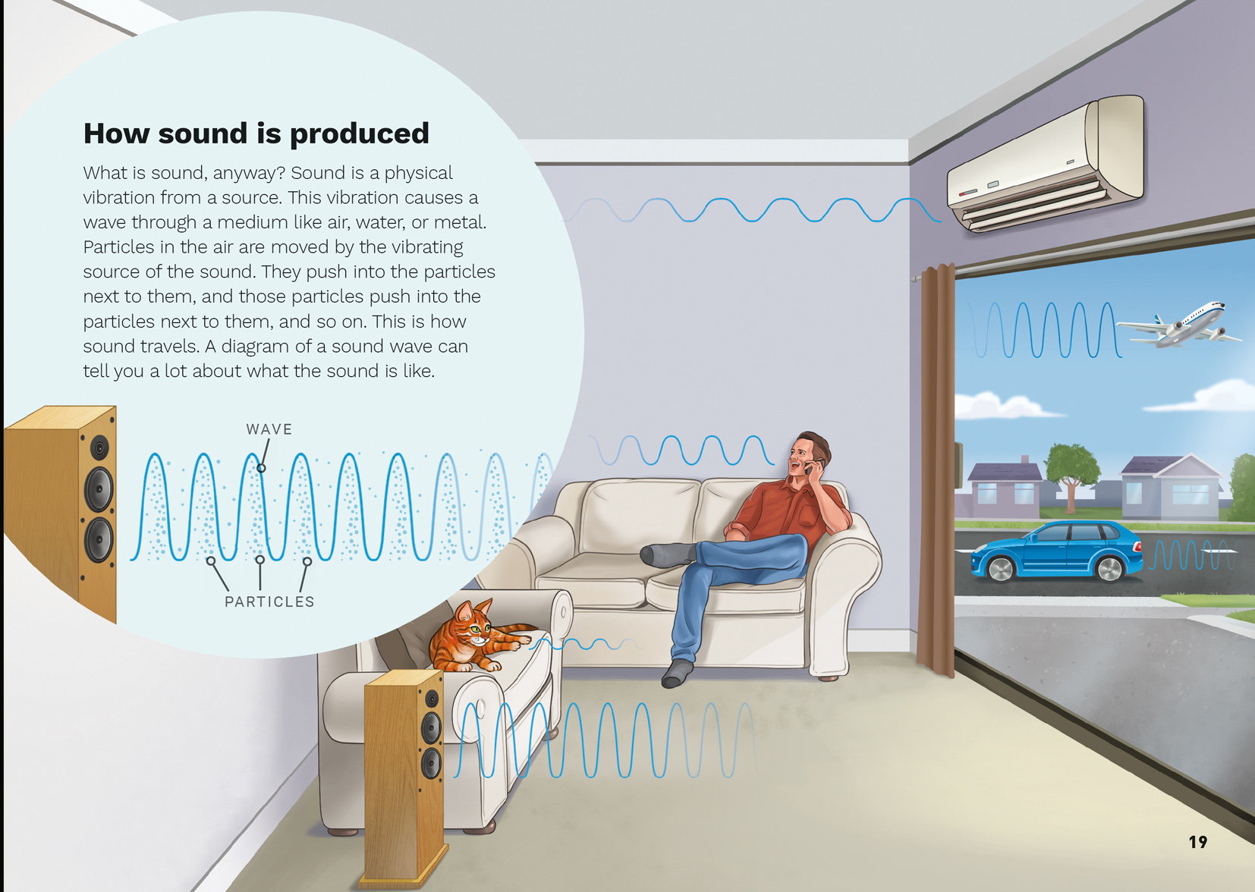  Scientists recognise how a model or representation does and doesn’t match the science.

Learning activities – Exploring the science
The following activities are a guide for supporting students to explore and develop understandings about the science capability “Interpret representations”. Some activities focus directly on the science capability. Other activities extend students’ content knowledge across the learning areas. Adapt these activities to support your students’ learning needs.

Activity 1 – Communicating our knowledge
Have the students conduct follow-up research on any questions they have on how sound is made or how we hear. These will have been recorded in the graphic organiser created earlier, but you will need to discuss them further to devise suitable questions for investigation. The purpose of this investigation is to increase students’ understanding of these processes so that they feel confident in explaining them to another person. One way of doing this may be to look at what happens to sound waves when they encounter different materials or to compare more closely how humans and other animals hear.
Have the students create their own explanations of these processes so that the similarities and differences are obvious. Explain that they are to critique each other’s work, focusing on both accuracy and on the way the ideas are represented.

Activity 2 – Helping us hear
If the students have not already done so, let them try the hearing tests mentioned in the text. If students have a hearing impairment, they may be prepared to share what this is like and how they manage it. Use this as a springboard to investigate the technology for dealing with hearing loss, from ear trumpets to hearing aids to cochlear implants.
- What do each of these technologies have in common?
- What might be the advantages of cochlear implants over traditional hearing aids?

Extending the learning
The students could research environmental risks to hearing, especially for teenagers.
- How prevalent is hearing loss among teenagers?
- What are some ways to avoid hearing loss?
Ask the students to present their findings in a way that will persuade other teenagers of the risks and the steps they could take to protect their hearing.

Activity 3 – Harnessing sound
Have the students investigate how sound is transmitted through a medium to human ears, then create a model to represent this. Use activities from books 18 and 19 in the Building Science Concepts series to explore how the properties of musical instruments are related to how they generate sound waves.
Students who are keen on music could explore how music is recorded or how it is amplified for a performance. Some background research on the technologies this involves could precede a visit to a recording studio, radio station, or performance venue. Have the students create presentations that explain the technology (for example, microphones, amplifiers, speakers, and mixer desks). The students might even like the opportunity to make a recording or put on a performance of their own.
Students who are less keen on music might prefer to do the opposite, exploring how we can soundproof rooms!

RESOURCE LINKS

Building Science Concepts  Book 18 – Exploring Sound: Using Sound-makers and Musical Instruments  Book 19 – Properties of Sound: How Sound-makers and Musical Instruments Work  Connected  “Amazing Sound”. Connected 2, 1998, pp. 26–28  “Sounds in Space”. Connected 2, 1998, pp. 29–31  Science Learning Hub  Resources related to sound: http://link.sciencelearn.org.nz/concepts/sound-waves | Other sources  “Sound”, Making Better Sense of the Physical World, pp. 23–34  BP Educational Service (A free UK site, but you will need to register to access the resources)  “What is sound?” (video – longitudinal wave, activity sheets, and teacher notes): http://bpes.bp.com/secondary-resources/science/ages-11-to-12/sound/what-is-sound-video/  Frequency and amplitude (video – pitch, frequency, volume and amplitude, activity sheets and teacher notes): http://bpes.bp.com/secondary-resources/science/ages-11-to-12/sound/frequency-and-amplitude-video/

Learning activities – Exploring the science

RESOURCE LINKS (continued)

Study jams  “Sound” (animated video): http://studyjams.scholastic.com/studyjams/jams/science/energy-light-sound/sound.htm  “The senses: Hearing” (animated video): http://studyjams.scholastic.com/studyjams/jams/science/human-body/hearing.htm  YouTube:  “What does sound look like?”: www.youtube.com/watch?v=px3oVGXr4mo (or on Vimeo https://vimeo.com/91446499)  Sound waves experiment using an amplifier and liquid: www.youtube.com/watch?v=jwMq8mmqgQ4  Ducksters  Basics of sound: www.ducksters.com/science/sound101.php  Sound: Pitch and acoustics: www.ducksters.com/science/sound102.php  Science experiment: Sound waves and pitch: www.ducksters.com/science/experiment_sound_pitch.php  Sound wave characteristics: www.ducksters.com/science/physics/sound_wave_characteristics.php  Science projects and experiments for kids (sound experiments): www.ducksters.com/science/kids_science_projects.php  Properties of waves: www.ducksters.com/science/physics/properties_of_waves.php  Hearing and the ear: www.ducksters.com/science/hearing_and_the_ear.php  The Physics Classroom  Interactive wave simulator: www.physicsclassroom.com/Physics-Interactives/Waves-and-Sound/Simple-Wave-Simulator/Simple-Wave-Simulator-Interactive  Sound is a mechanical wave: www.physicsclassroom.com/class/sound/Lesson-1/Sound-is-a-Mechanical-Wave  Sound as a longitudinal wave: www.physicsclassroom.com/class/sound/Lesson-1/Sound-as-a-Longitudinal-Wave  Pitch and frequency: www.physicsclassroom.com/class/sound/Lesson-2/Pitch-and-Frequency  Other resources about human’s hearing and hearing loss  The Children’s University of Manchester  How the ear works: www.childrensuniversity.manchester.ac.uk/interactives/science/brainandsenses/ear/ | Kids Health  Your ears: http://kidshealth.org/en/kids/ears.html  Can loud music hurt my ears? http://kidshealth.org/en/kids/rock-music.html  EgoPont  Test your hearing range: www.egopont.com/hearing_tests.php  Other resources about animals’ hearing  The hearing ranges of animals: Which animals hear best?: www.myihp.co.uk/animal-hearing-ranges/  Sonar  NOOA Fisheries: Sonar and marine mammals’ fact sheet: www.nmfs.noaa.gov/pr/pdfs/health/sonar_fact_sheet.pdf  Pets on Mom.Me  Animal hearing: http://animals.mom.me/can-animals-hear-noises-others-cannot-5888.html  Wonderopolis  How can dogs hear things we can’t?: http://wonderopolis.org/wonder/how-can-dogs-hear-things-we-cant-2/  The Physics Factbook  Frequency of bat sonar: http://hypertextbook.com/fats/1998/JuanCancel.shtml  Frequency range of dog hearing: http://hypertextbook.com/facts/2003/TimCondon.shtml  Learn NC  “How sound is like a wave: Investigating animal echolocation”: www.learnnc.org/lp/editions/biomusic/6514  Other resources about music and sound  Hearing Association of New Zealand: www.hearing.org.nz/  The science of sound for kids: www.sciencekids.co.nz/sound.html  iOS Apps for science teachers: Teaching about sound: www.whiteboardblog.co.uk/2013/01/ipad-apps-for-teaching-about-sound/  Music science fair project ideas: www.sciencebuddies.org/science-fair-projects/Intro-Music-Science.shtml  Other resources about soundproofing  Soundproof package lesson plan: http://mindtrekkers.mtu.edu/lessons/90.pdf

